COURSE CODE/TITLE: | CPE 007/Programming Logic and descipline |  | SECTION: | CPE11S4
DATE PERFORMED: | 15/09/2026 |  | DATE SUBMITTED: | 15/09/2026
NAME: | John Mark J. Barbacena |  | INSTRUCTOR: | Sir Robin Valenzuela

ACTIVITY NO. 4.2 | [Character and Strings]
1. PROCEDURE OUTPUT
What procedures did you perform?#include <iostream>
#include <cctype>
using namespace std;

int main() {
char ch;
for (int i = 1; i <= 4; i++) {
cout << "Enter a character: ";
cin >> ch;
if (islower(ch))
cout << ch << " is a lowercase letter" << endl;
else
cout << ch << " is not a lowercase letter" << endl;
if (isupper(ch))
cout << ch << " is an uppercase letter" << endl;
else
cout << ch << " is not an uppercase letter" << endl;
cout << "Converted to uppercase: " << (char)toupper(ch) << endl;
cout << "Converted to lowercase: "<< (char)tolower(ch) << endl;
cout << endl;
}
}

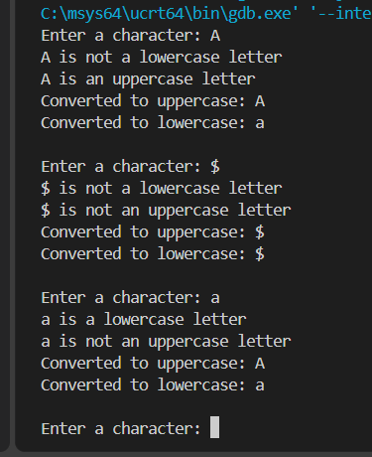
2. ANSWERS TO SUPPLEMENTAL ACTIVITY
Copy and paste the questions from the lab and include your answers after.
For each of the following, Create the following C++ Code and output for each case:
1. Write a C++ program that accepts a character input from the keyboard and tests the character using each
function in the <cctype> character-handling library. Display the result of each function.
#include <stdio.h>
#include <ctype.h>

int main() {
char ch;

printf("Enter a character: ");
scanf("%c", &ch);

printf("\nResults:\n");

printf("isalnum: %d\n", isalnum(ch));
printf("isalpha: %d\n", isalpha(ch));
printf("isdigit: %d\n", isdigit(ch));
printf("islower: %d\n", islower(ch));
printf("isupper: %d\n", isupper(ch));
printf("isspace: %d\n", isspace(ch));
printf("ispunct: %d\n", ispunct(ch));
printf("isxdigit: %d\n", isxdigit(ch));
printf("isprint: %d\n", isprint(ch));
printf("isgraph: %d\n", isgraph(ch));
printf("iscntrl: %d\n", iscntrl(ch));

printf("toupper: %c\n", toupper(ch));
printf("tolower: %c\n", tolower(ch));

return 0;
}
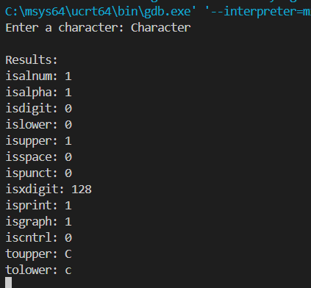
2. Write a C++ program that accepts four strings representing integers, converts them into integer values,
calculates their sum, and displays the total.
#include <iostream>
#include <string>
using namespace std;

int main() {
string num1, num2, num3, num4;

cout << "Enter first integer: ";
cin >> num1;

cout << "Enter second integer: ";
cin >> num2;

cout << "Enter third integer: ";
cin >> num3;

cout << "Enter fourth integer: ";
cin >> num4;

int n1 = stoi(num1);
int n2 = stoi(num2);
int n3 = stoi(num3);
int n4 = stoi(num4);

int sum = n1 + n2 + n3 + n4;

cout << "\nTotal: " << sum << endl;

return 0;
}
3. Write a C++ program that accepts a password as a string and determines whether it meets all of the
following requirements:
● Contains at least one uppercase letter
● Contains at least one lowercase letter
● Contains at least one digit
● Contains at least one punctuation character
● Contains no whitespace characters
● Contains at least 8 characters
#include <iostream>
#include <string>
#include <cctype>
using namespace std;

int main() {
string password;

cout << "Enter password: ";
getline(cin, password);

bool uppercase = false;
bool lowercase = false;
bool digit = false;
bool punctuation = false;
bool whitespace = false;

for (char ch : password) {

if (isupper(ch))
uppercase = true;

if (islower(ch))
lowercase = true;

if (isdigit(ch))
digit = true;

if (ispunct(ch))
punctuation = true;

if (isspace(ch))
whitespace = true;
}

bool length = password.length() >= 8;

cout << "\nPassword Requirements:" << endl;

cout << "Uppercase letter: ";
if (uppercase)
cout << "Satisfied" << endl;
else
cout << "Not Satisfied" << endl;

cout << "Lowercase letter: ";
if (lowercase)
cout << "Satisfied" << endl;
else
cout << "Not Satisfied" << endl;

cout << "Digit: ";
if (digit)
cout << "Satisfied" << endl;
else
cout << "Not Satisfied" << endl;

cout << "Punctuation character: ";
if (punctuation)
cout << "Satisfied" << endl;
else
cout << "Not Satisfied" << endl;

cout << "No whitespace: ";
if (!whitespace)
cout << "Satisfied" << endl;
else
cout << "Not Satisfied" << endl;

cout << "At least 8 characters: ";
if (length)
cout << "Satisfied" << endl;
else
cout << "Not Satisfied" << endl;

if (uppercase && lowercase && digit &&
punctuation && !whitespace && length)
cout << "\nPassword is VALID." << endl;
else
cout << "\nPassword is INVALID." << endl;

return 0;
}
3. ARTIFICIAL INTELLIGENCE (AI) USE DISCLOSURE STATEMENT
I hereby declare that artificial intelligence (AI) tools were used, if applicable, in the preparation of this academic work. The following indicates the nature and extent of AI assistance:

Tools Used:
Examples: ChatGPT, Microsoft Copilot, Grammarly, QuillBot, etc.

Purpose of Use:
Examples: grammar correction, idea generation, formatting, summarization, code assistance, explanation of concepts, etc.

Extent of Use:
Explain how AI was used and confirm that it did not replace original thinking, analysis, authorship, or completion of the required work.

By submitting this activity, I affirm that my use of AI complies with T.I.P.’s AI usage policy and does not exceed the permitted limits for similarity, automated content generation, or academic assistance.

I understand that any false, incomplete, or misleading disclosure may be subject to investigation in accordance with due process and may result in sanctions for violation of existing T.I.P. policies.

Lab activities, templates, and related instructional materials shall not be reuploaded, reproduced, distributed, or shared with external organizations or third parties without the prior express written permission of the Technological Institute of the Philippines.

